TJX GUI - User guide

1. Open the TJX GUI. The user interface looks as shown in the following figure.

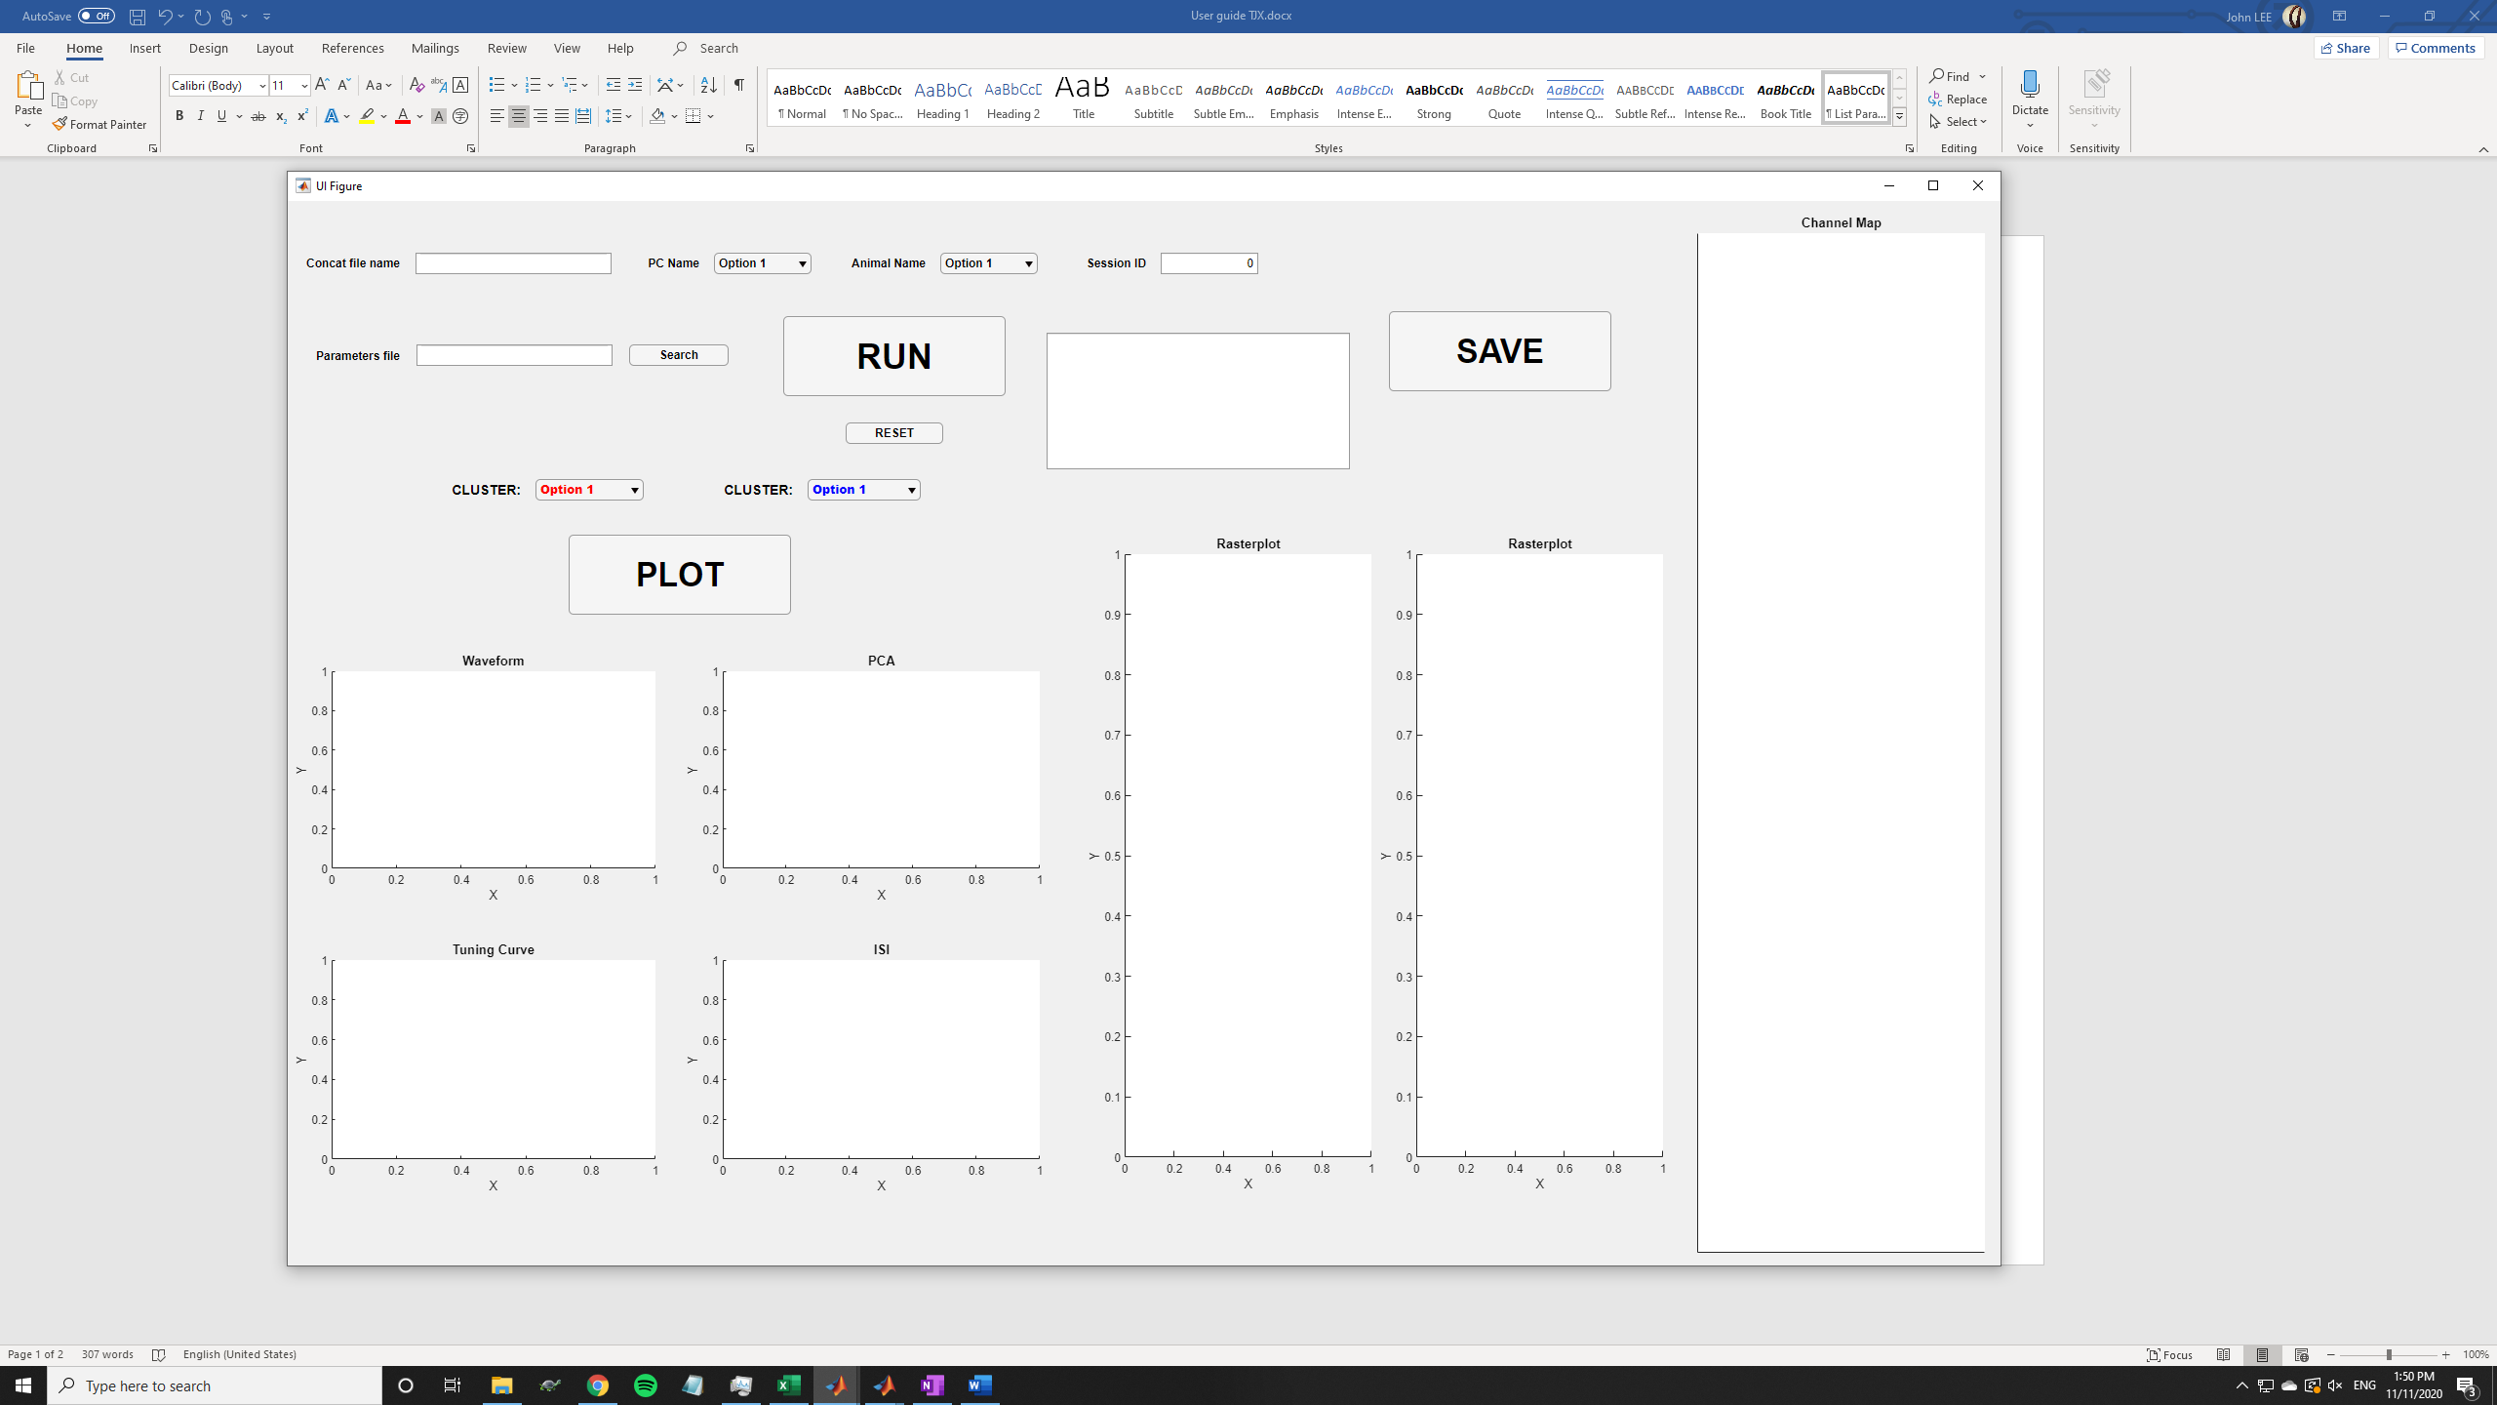

1. Select the folder where the data is stored (concat folder) and load it into the GUI. The folder should have a name ending with “concat” (example: “H13T5S2_concat”).
2. Select your designated parameters file. This file should always have the structure shown in the following figure. Remember to NOT MODIFY this parameters file, or if you are creating your own parameters file, remember to follow the exact structure.

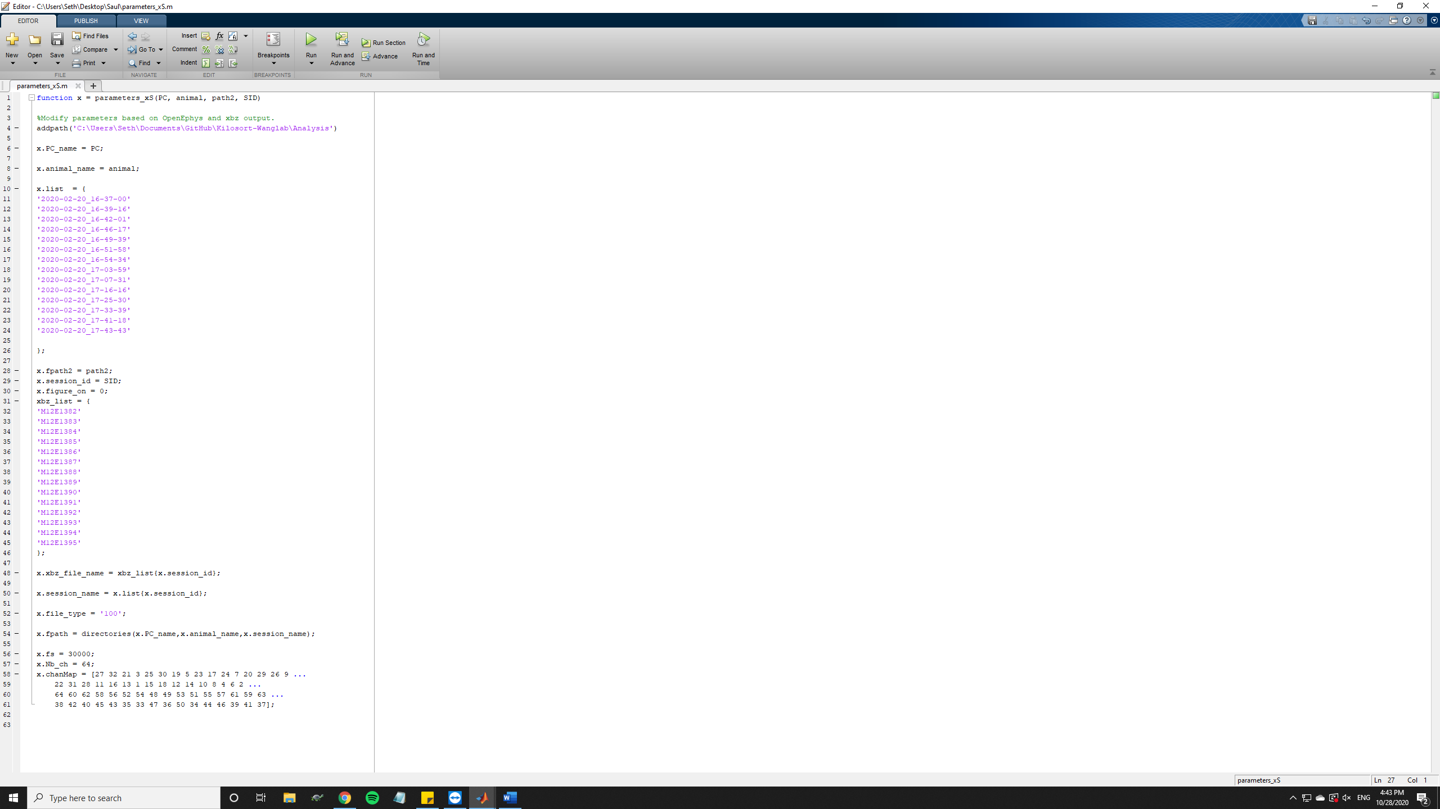

1. After selecting your parameters file, you should now have some options in the dropdown menus of **PC Name** and **Animal Name.** Next, select the options corresponding to the name of the computer you are using and the name of the animal of study. Please note: the options shown in the dropdown button of PC Name and Animal Name are preset in the file called **“data_file.m”**. If you wish to add more options to be shown in the dropdown menu, please modify that file, DO NOT modify the parameters file.

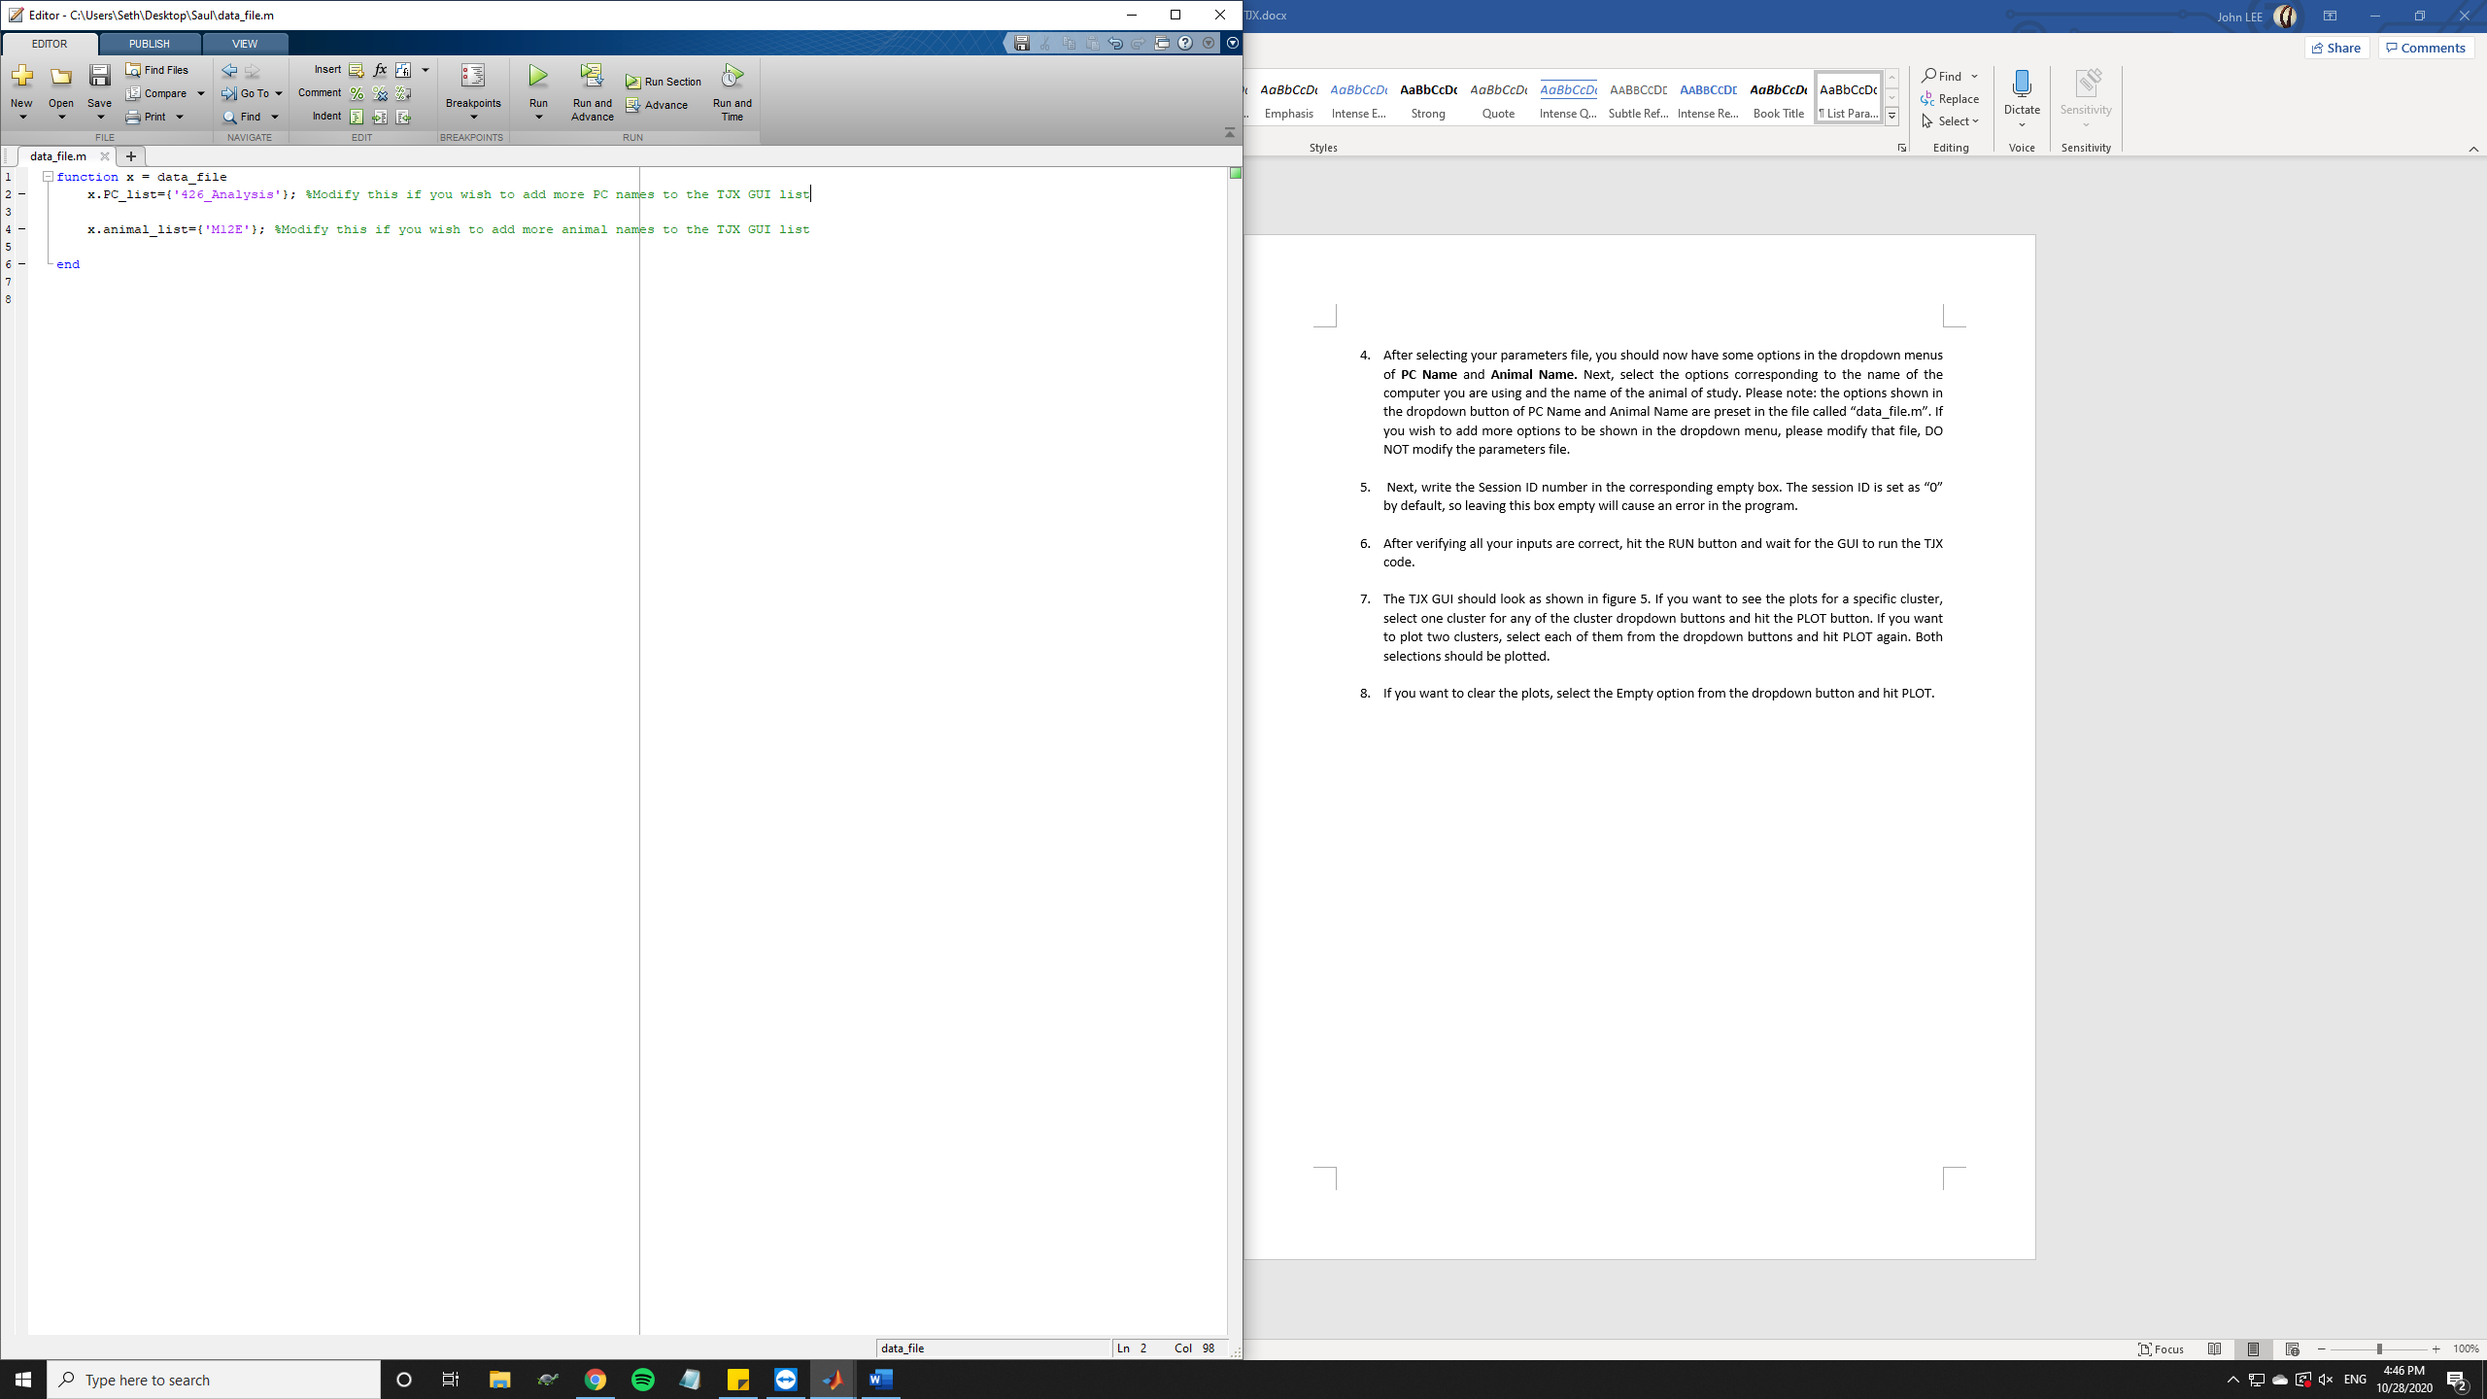

1. Next, write the Session ID number in the corresponding empty box. The session ID is set as “0” by default, so leaving this box empty will cause an error in the program.
2. After verifying all your inputs are correct, hit the RUN button and wait for the GUI to run the TJX code.
3. When the processing is done, the TJX GUI should look as shown in the next figure. If you want to see the plots for a specific cluster, select one cluster for any of the cluster dropdown buttons and hit the PLOT button. If you want to plot two clusters, select each of them from the dropdown buttons and hit PLOT again. Both selections should be plotted.

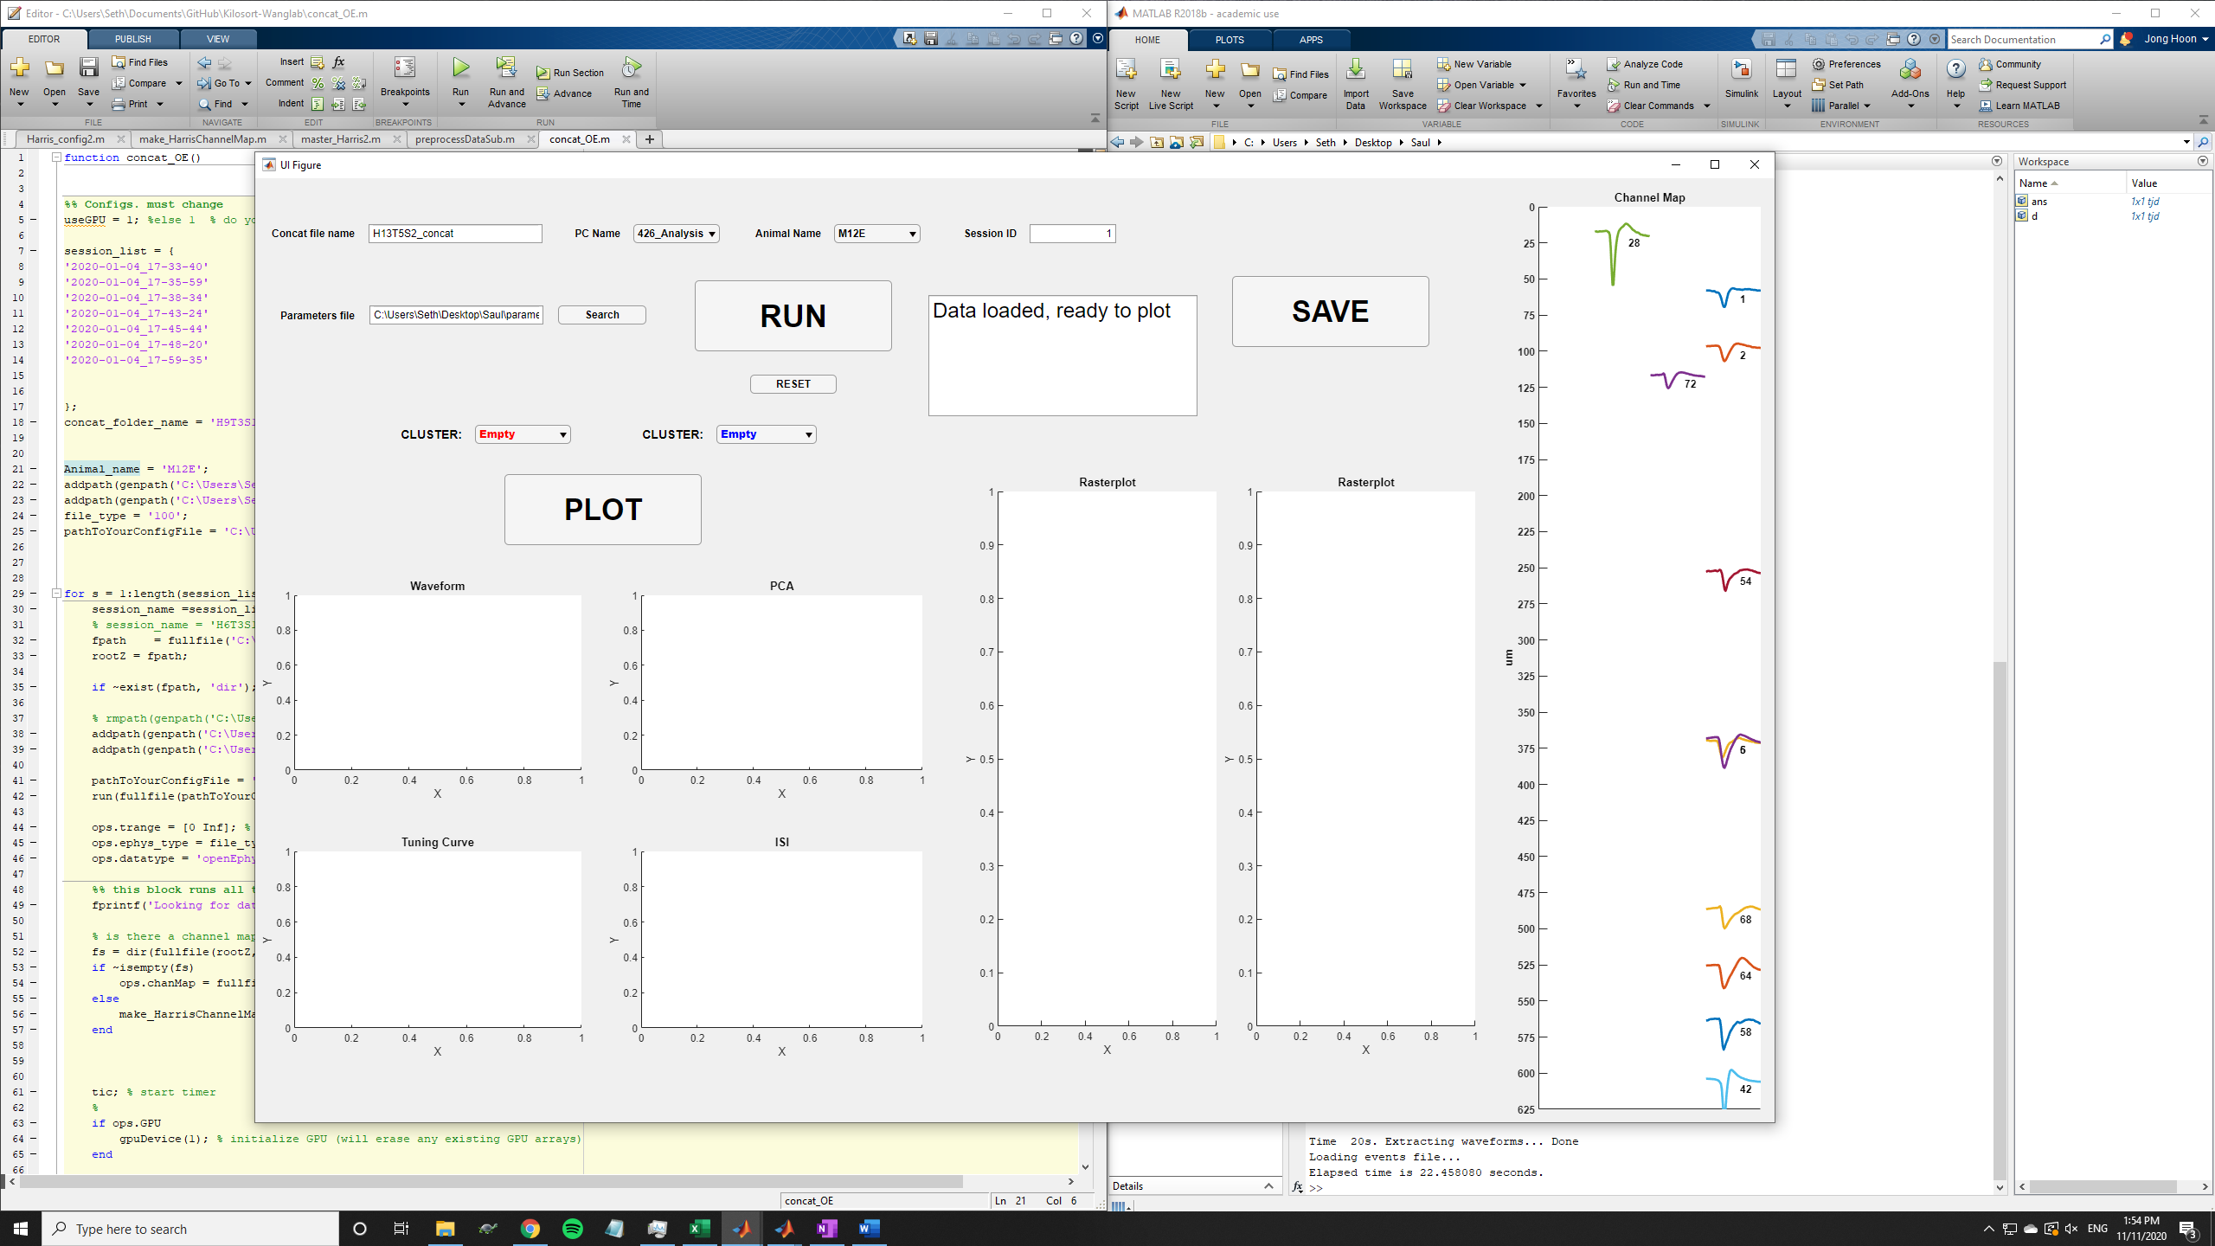

1. If you want to clear the plots, select the Empty option from the dropdown button and hit PLOT again.
2. If you want to run the user interface again with different inputs, press RESET (located below the RUN button) to clear all the inputs and outputs and then run the GUI again.